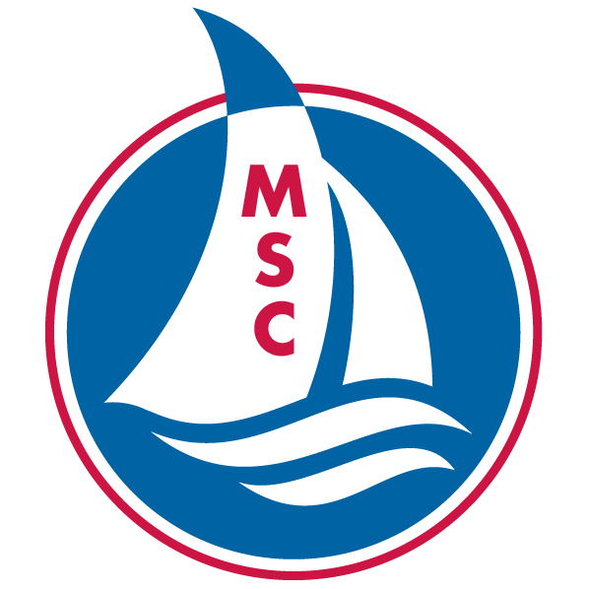
MINNEAPOLIS SAILING CENTER
2735 FREMONT AVE S #2 MINNEAPOLIS, MN 55408 | 612-470-SAIL (7245)

SCHOLARSHIP APPLICATION
Our mission is to teach sailing to all and to help reach that goal, we provide need-based scholarships for our classes as allowed by donations from generous contributors.

Please complete all sections of this application and return to info@sailmpls.org. Information provided is confidential. Upon receipt, we will review your application and notify you if the scholarship is approved, how much assistance will be granted, and how to register for classes. Scholarship funds cover only the class tuition for our program.

CONTACT INFORMATION
Parent/Guardian Name: Date:
Address:
City: State: Zip:
Phone: E-mail:

APPLICANT AND FAMILY
Name of students applying for scholarship
Name: Age:
Name: Age:
Name: Age:

Total number of Individuals in household:
Total household income for past year:
Employer Name: Employer Phone:
Other sources of income and amount:

What amount can you afford to pay towards the tuition of students for each session?

CLASSES
Class and session dates applied for:

ADDITIONAL INFORMATION
Please provide any information regarding your need for financial assistance that will help us determine scholarship status:

SIGNATURE
By signing my name below, I certify that all information provided on this application is complete, true, and accurate.

Parent/Guardian Signature: Date:

